Sprint 1 Plan

Circular

Release 1.0

Completion Data: 1/31

Revision Number: 1

**Sprint Goal**: To create a basic version of the website where we can see posts.

Tasks

*User Story 1: (5) As a user, I want a list view of items for barter so I can find out what’s available in Santa Cruz.* ***Must***

* Tasks
  + Create a listings page (2)
  + Set up database data structure (1)
  + Fetch info from database to update listings (2)

*User Story 2: (5) As a person who doesn’t want to spend too much time on creating an account, I want to create my account with Google.* ***Must***

* Tasks
  + Use google api for account creation (2)
  + Store relevant user data in backend (2)
  + create sign in and sign out buttons (1)

*User Story 3: (5) As someone who wants to give something away, I want to be able to create and post a listing so that other users can make offers.* ***Could***

* Tasks
  + Create a page where users can fill out the information for the listing being posted, including images (3)
  + Send post request to server and have it stored in the database (2)

*User Story 4(8): As a potential user, I want to use a website with an intuitive and aesthetically pleasing design to achieve my goals.* ***Should***

* Tasks
  + 2a Plan out the user flows/storyboard (1)
  + 2b Sketch pages (1)
  + 2c Create a Prototype in Figma (2)
  + 2d Test Prototype (1)
  + 2e Generate React code from prototype (1)
  + 2d Connect frontend, backend, and database (2)

**Team Roles**

* Ian (Product Owner, UI Designer)
* Kenneth (Scrum Master, backend)
* Gonzalo (developer, full stack)
* Hengtian (developer, frontend)
* Micheal (developer, backend)
* Daniel (developer, )

**Initial Task Assignment**

* Ian: 2a
* Kenneth: 1a, 1b, 3b, 2d
* Gonzalo:
* Hengtian: 2c, 3a
* Micheal 1b, 2d, 3b
* Daniel: get technologies installed

Infrastructure Tasks:

* Get everything installed (Visual Studio Code, node.js, react, PostgreSQL, git) (8)
* Make a setup README

**Initial burnup chart**

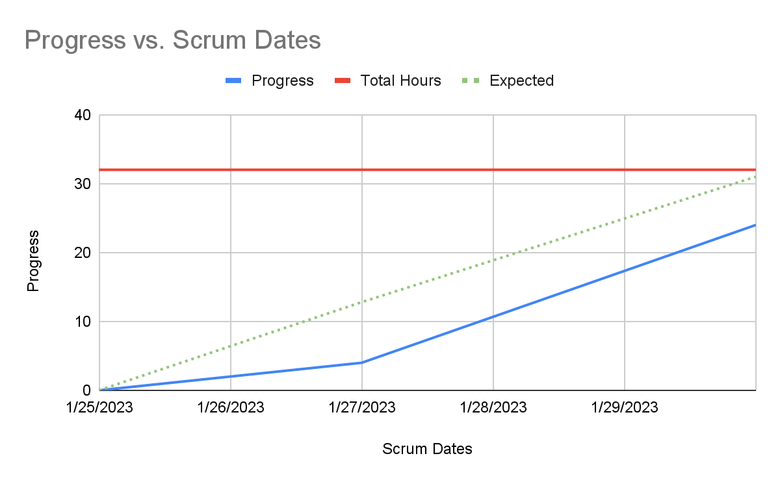

[**Initial Scrum Board**](https://trello.com/invite/b/gx6MgIyB/ATTI05a8695a17ffdbae9ebdfa6643b1ffb3EFEE51C2/tasks)

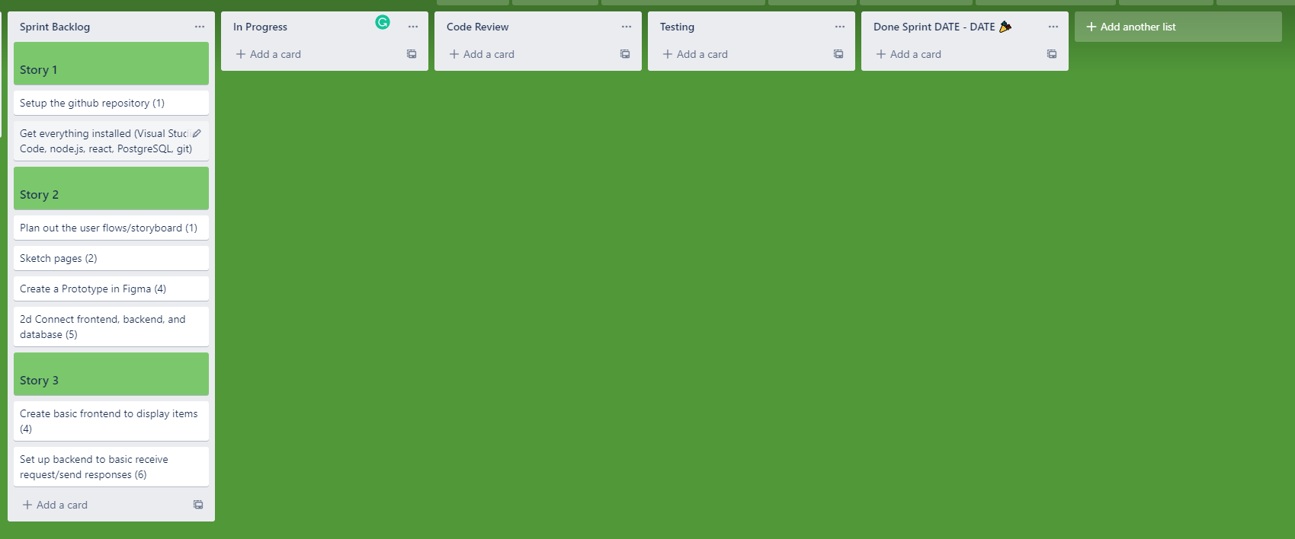

**Scrum Times:**

9:05 - 9:20 MWF